(**you MUST use hy.ed.voicethread.com, NOT voicethread.com)
STEP #1: Login
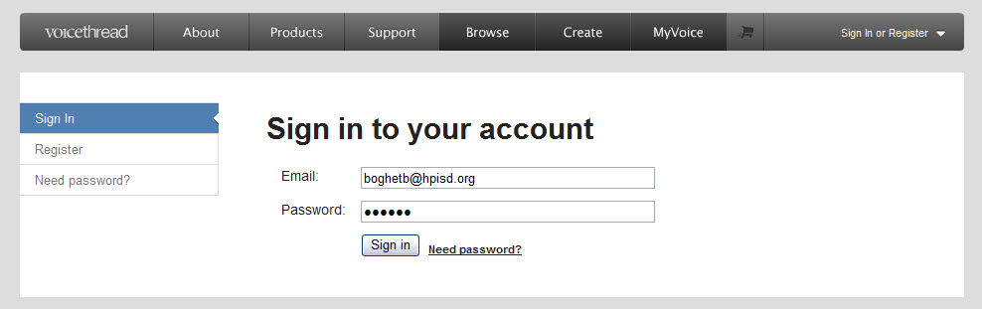
Login: Novell@hpisd.org
Password: huskey

STEP #2: Choose what you would like to do.
- You will see 3 different tabs :Browse, Create, and MyVoice
- “MyVoice” tab will show your saved documents, you will not have any YET
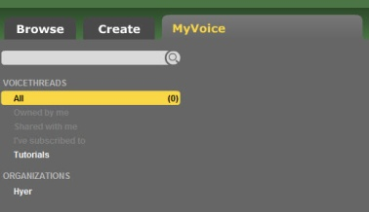
- Choose the “Create” Tab to create a
new VoiceThread to share with your class
- Browse” allows you to search other projects
that have been shared across the web.
It is a GREAT place to see how other people are using this program in their classrooms.

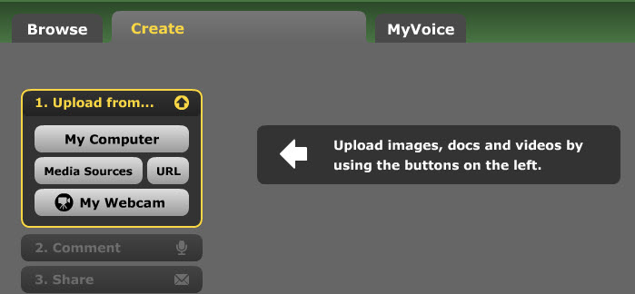
STEP #3: Upload the document/image you would like for your students to use. **You will want to have saved the item in your H: drive

-You will be able to share and use the document as soon as it shows up on your screen.

STEP #4: Add a Title and Description of your slide
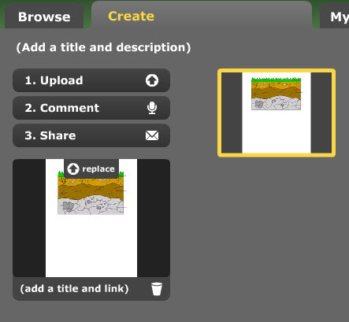
*This will help students find the correct document, give them directions, as well as remind you of the task.
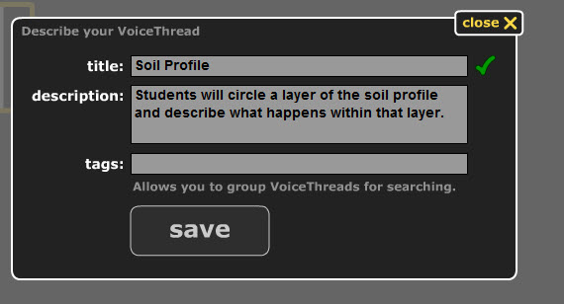

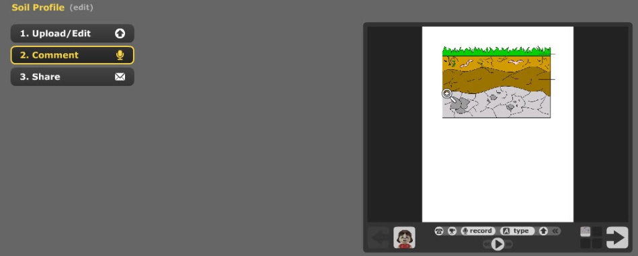
STEP #5: Comment and give directions to your students.
You can choose to:
- Phone in directions
- Video in directions
- Record w/ a microphone
- Type words

*You will be able to annotate over the document to help support your comments.
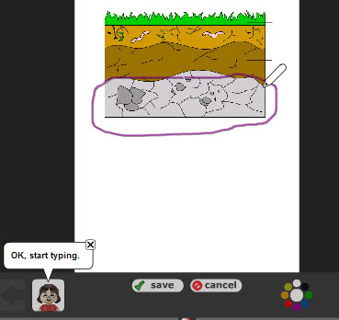
-Once you begin commenting, a pencil with color palate will show up. Use this to annotate after your comments are displayed.

*The annotations will show up after
your comment has popped up on
the screen.

**You do not necessarily need to add this, but it is an option. Students will also have the ability to comment and annotate.

**Make sure to SAVE when you are finished with this step.

STEP #5: Create your class and share your document.
- Choose SHARE
- You will need to create your own group.
*A pop-up menu will come up, close it (it will tell you the ways to share)
- Go back to the Groups and choose HYER
- Search for your students- then DRAG and DROP them into your newly created class group.
4.
1.
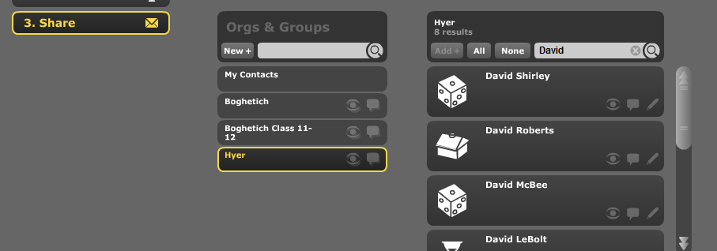
2-3

*Once you have created a group, you will not have to repeat this process (you can always go back and add/drop students)
***In order to share, you need to select ALL of your students in your group (you will know that they are all selected when they have a yellow circle around their name)
You will need to make sure that, within your group name, you choose the EYE and the COMMENT box..This will allow everyone in that group to be able to see and comment on the document.

CONGRATULATIONS!! Your document is now ready for the kids to see and use!

SO….How can they see it and comment?
They will need to
- LOGIN
Student Logins are: Novell User@hy.ed.voicethread.com
:Password: huskey
- Choose MY VOICE
- Find GROUPS
- SELECT the document they would like to work on.

